|  |  |  |  |
| --- | --- | --- | --- |
| FACULTY OF ENGINEERING |  | CAIRO UNIVERSITY |  |
| 4th Year | | | |
| Course: Electrical Power Systems (3)  (EPE4010) | | | |

|  |  |  |  |
| --- | --- | --- | --- |
| B.N. | Section | ID | Name |
| 8 | 1 | 9202065 | Ahmed Tawheed Abd-AlRazik |
| 47 | 2 | 9202857 | Abdallah Osama Hussein AbdAlmoneim |
| 29 | 3 | 9203173 | Mohamed Ashraf Mabrouk EL-Abd |
| 31 | 3 | 9203193 | Mohamed Gamal Hob El-Din Torky |

Assignment no.: HW1 - HW2

Instructor: Dr. Mohamed Rabah

Date: 26/12/2023

# TABLE OF CONTENTS

TABLE OF CONTENTS 2

Acceleration time from 60mph – 80mph: 3

System Modification: 3

Initiation model: 4

Results: 5

Acceleration time from 60mph – 80mph: 6

System Modification: 6

6

Initiation Model: 7

Results: 8

Basic EV model development to validate acceleration specification. 9

Validation of acceleration specification using a basic EV simulation model 9

INITIAL CONDITIONS 9

Verify the analytical results of (a) via simulation using the following steps: 10

Build the basic EV Simulink simulation model described in the “Intro to MATLAB/Simulink” supplementary lecture (posted online with the course lectures) 11

Simulate the model with the parameters above and show the resulting plot with speed v [mph] and tractive propulsion force Fv [N] and the solved acceleration time ta. 12

Verify the analytical results of (b) via simulation using the following steps 13

System Simulation of Leaf-Sized Electric Vehicle 18

Run the driving cycle eudc with tstop=1200 at two gear ratios, gratio = 7.94 and version from (a). 20

HW1

# Acceleration time from 60mph – 80mph:

## System Modification:

Modification of the input drive cycle to step input changes from 60mph (26.82 m/s) to 80mph (35.76 m/s) to test the response of the model and the acceleration time needed to reach 80mph.

## A screenshot of a computer Description automatically generatedInitiation model:

## A screenshot of a computer Description automatically generatedA screenshot of a computer Description automatically generatedResults:

Ta = (16.88 - 16.66) * 60 = 13.2 sec

# Acceleration time from 0 mph – 60mph:

## System Modification:

Modification of the input drive cycle to step input changes from 0 mph (0 m/s) to 60mph (26.82 m/s) to test the response of the model and the acceleration time needed to reach 0 mph.

## A screenshot of a computer Description automatically generatedInitiation Model:

## Results:

Ta = 0.2459 * 60 = 14.754 sec

HW2

# Basic EV model development to validate acceleration specification.

# Validation of acceleration specification using a basic EV simulation model

## INITIAL CONDITIONS

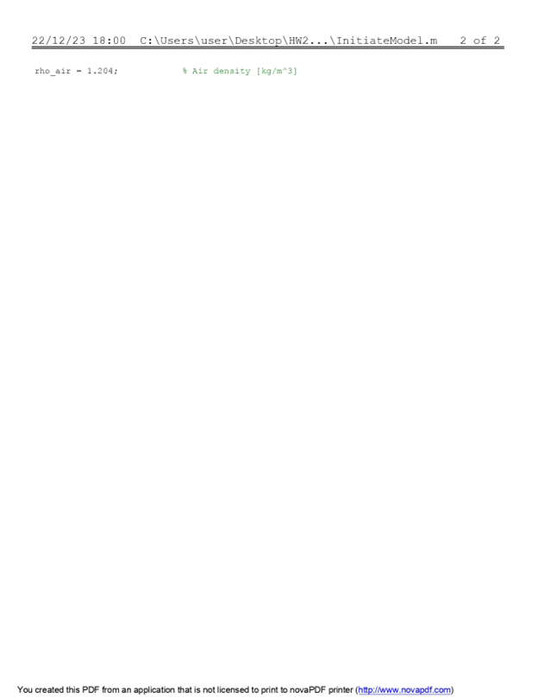

## Verify the analytical results of (a) via simulation using the following steps:

*N.B. 1: a) Solve the approximate accelerate time ta from 0 to 60 MPH.*

*N.B. 2: 60MPH = 26.8224 M/S.*

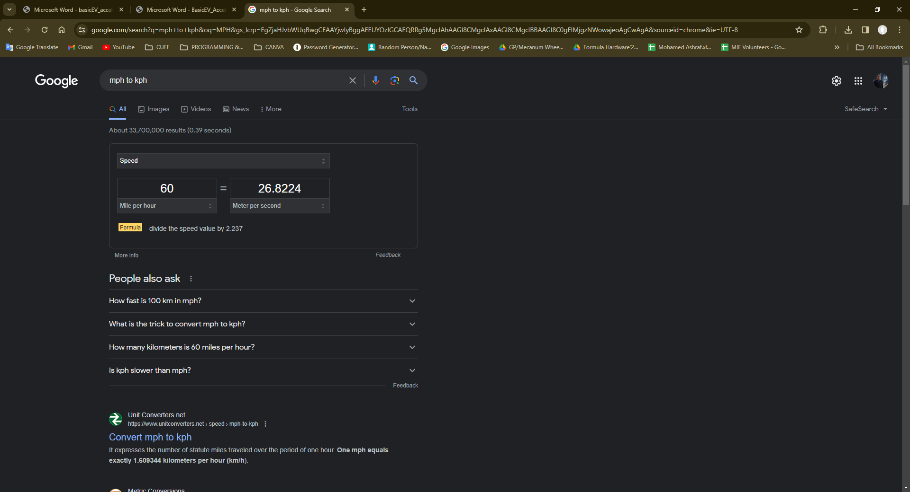

## Build the basic EV Simulink simulation model described in the “Intro to MATLAB/Simulink” supplementary lecture (posted online with the course lectures)

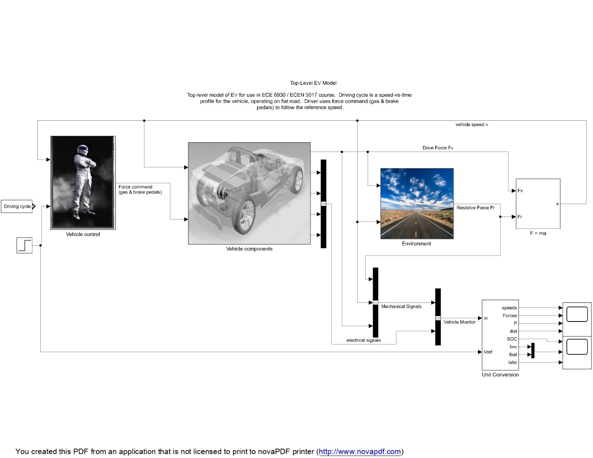

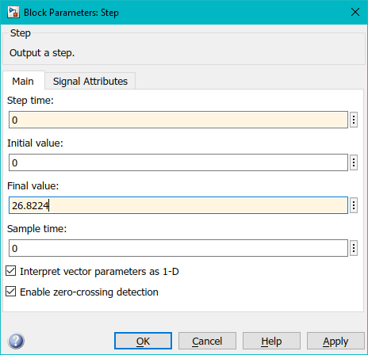

## Simulate the model with the parameters above and show the resulting plot with speed v [mph] and tractive propulsion force Fv [N] and the solved acceleration time ta.

OUTPUTS OF THE SIMULATION (v, Fv, DISTANCE)

CLOSE VIEW OF THE OUTPUTS (t=0-0.5 min)

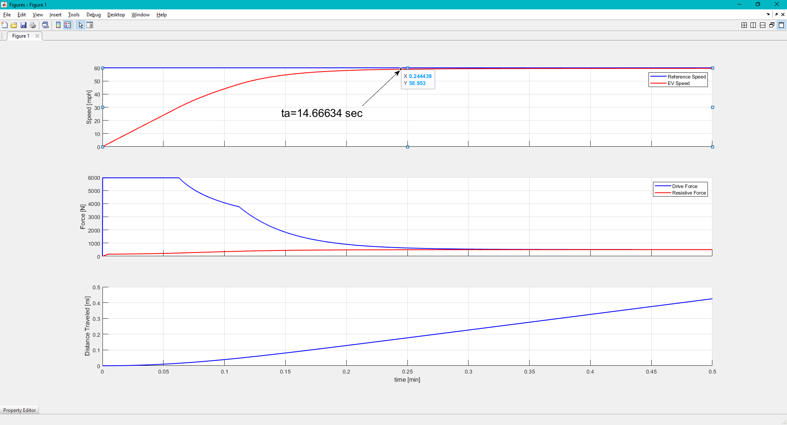

## Verify the analytical results of (b) via simulation using the following steps

• Modify the basic EV model to include the following signals

* Vehicle tractive power Pv
* Battery power, Pbatt = Pv / ηtw
* Total battery energy used, Ebatt (integral of battery power)

• Modify the PlotEVData.m file to add two additional subplots with the signals

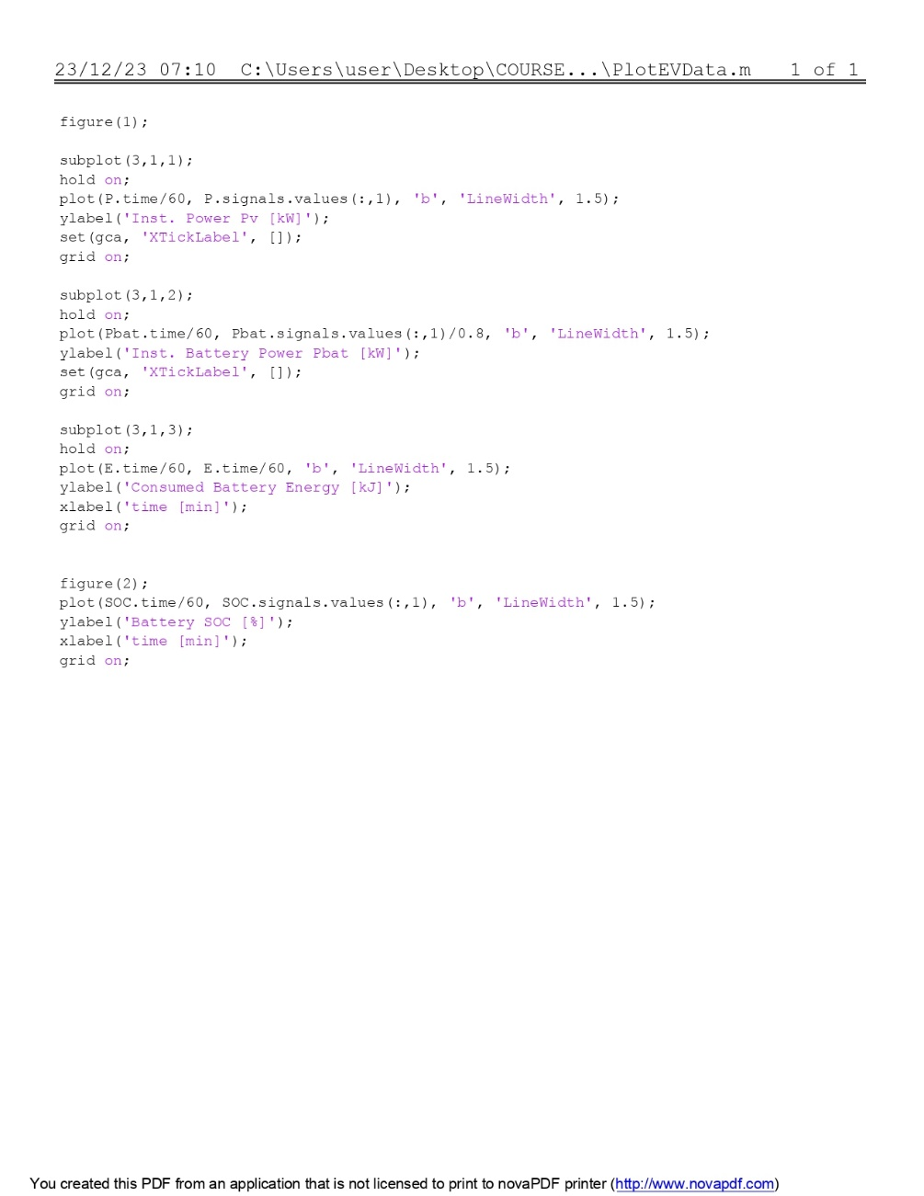

* Pv and Pbatt
* Ebatt

GRAPH 1: Pv GRAPH 2: Pbat GRAPH 3: Ebat

BATTERY SOC

# System Simulation of Leaf-Sized Electric Vehicle

For the vehicle cruising in steady-state with velocity Vcruise = 50 mph on a flat road,

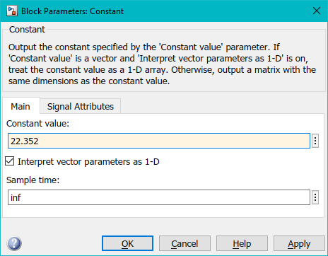

* Calculate the vehicle power Pv required to maintain cruise velocity

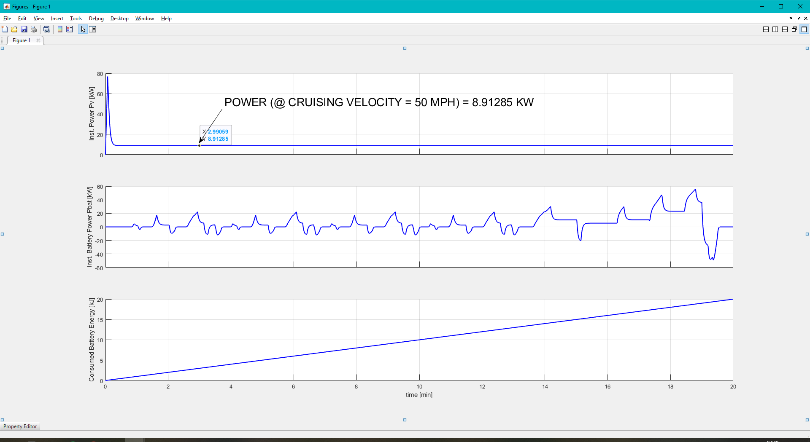

## Run the driving cycle eudc with tstop=1200 at two gear ratios, gratio = 7.94 and version from (a).

* Measure and report the total energy taken from the battery over the course of the entire driving cycle with your optimal gratio
* Compare the two gear ratios in terms of ending SOC and MPGe

GEAR RATIO=7.94

Ebatt SOC MPGe

* Turn in the plots of the motor torque Tm vs angular speed ωm path of the vehicle over the drive cycle overlaid on the motor efficiency contours

GEAR RATIO = 7.94

